TŠRB stranica škole

<http://ss-tehnicka-rboskovica-vk.skole.hr/>

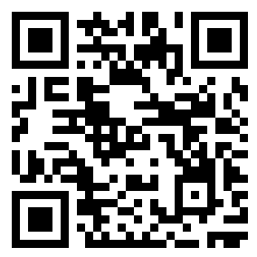

TŠRB Facebook

<https://www.facebook.com/TSRBVK.sluzbenastranica>

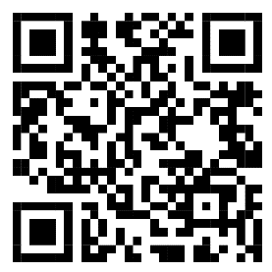

TŠRB YouTube

<https://www.youtube.com/channel/UCc-HfqmUruc_qd0PFBGVqTQ>

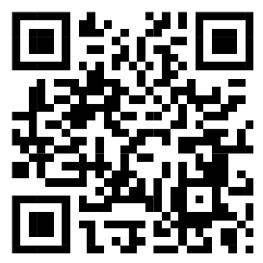

Video ROBODAN

<https://www.youtube.com/watch?v=Rca4KHByK_o>

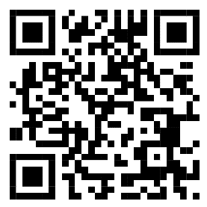

Godišnjak 2021./2022.

<https://drive.google.com/file/d/1aU5j6y8fF9Iblk1FNMjbEX0Nyoe_HZGV/view>

